## **Docker Services**

## **To deploy an application image when Docker Engine is in swarm mode, you have create a service. A service is a group of containers of the same image:tag. Services make it simple to scale your application.**

## **In order to have Docker services, you must first have your Docker swarm and nodes ready.**

## 

## **Using Services**

In order to create a service you need to use the following command:

docker service create --name bobby-web -p 80:80 --replicas 5 bobbyiliev/php-apache

Note that I already have my bobbyiliev/php-apache image pushed to the Docker hub as described in the previous blog posts.

To get a list of your services run:

docker service ls

Output:

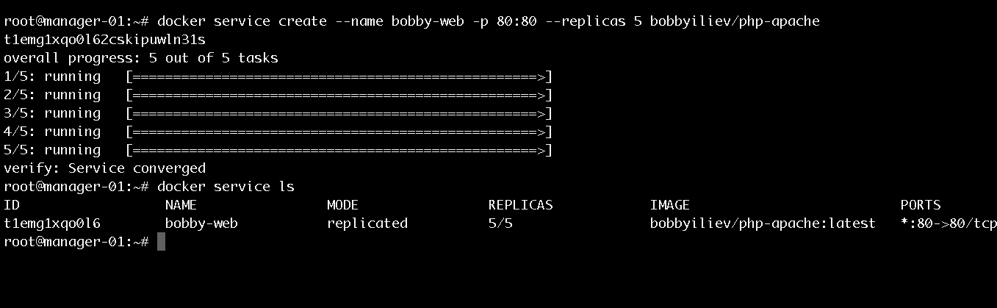

Then in order to get a list of the running containers you need to use the following command:

docker services ps name_of_your_service_here

Output:

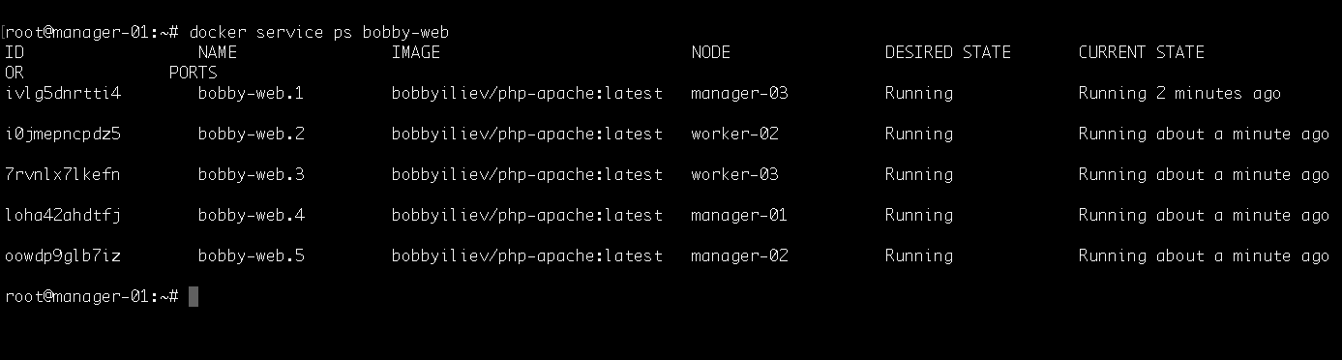

Then you can visit the IP address of any of your nodes and you should be able to see the service! We can basically visit any node from the swarm and we will still get the to service.

## **Scaling a service**

We could try shutting down one of the nodes and see how the swarm would automatically spin up a new process on another node so that it matches the desired state of 5 replicas.

To do that go to your DigitalOcean control panel and hit the power off button for one of your Droplets. Then head back to your terminal and run:

docker services ps name_of_your_service_here

Output:

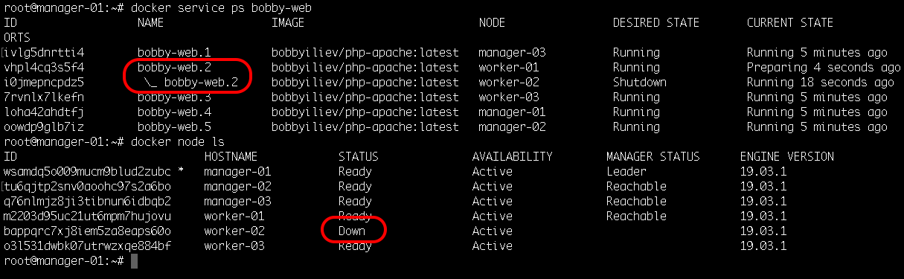

In the screenshot above, you can see how I've shutdown the droplet called worker-2 and how the replica bobby-web.2 was instantly started again on another node called worker-01 to match the desired state of 5 replicas.

To add more replicas run:

docker service scale name_of_your_service_here=7

Output:

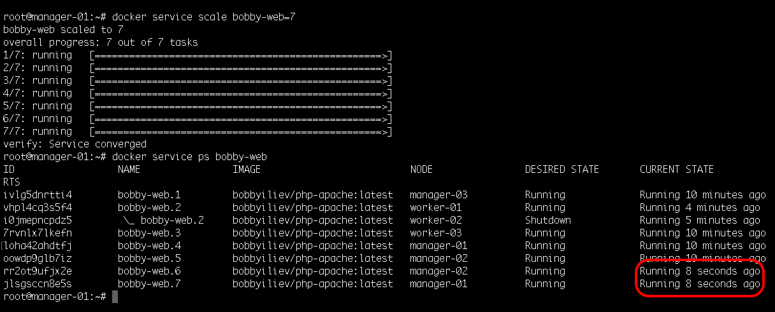

This would automatically spin up 2 more containers, you can check this with the docker service ps command:

docker service ps name_of_your_service_here

Then as a test try starting the node that we've shutdown and check if it picked up any tasks?

Tip: Bringing new nodes to the cluster does not automatically distribute running tasks.

## **Deleting a service**

In order to delete a service, all you need to do is to run the following command:

docker service rm name_of_your_service

Output:

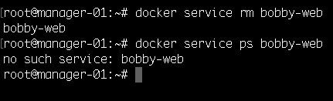

Now you know how to initialize and scale a docker swarm cluster! For more information make sure to go through the official Docker documentation [here](https://docs.docker.com/engine/swarm/).